ish¿u ysñlï weúßKs $ All Rights Reserved

St. Peter's College

St. Peter's College

St. Peter's College

புனித பேதுரு கல்லூரி

புனித பேதுரு கல்லூரி

புனித பேதுரு கல்லூரி

புனித பேதுரு கல்லூரி

புனித பேதுரு கல்லூரி

புனித பேதுரு கல்லூரி

புனித பேதுரு கல்லூரி

புனித பேதுரு கல்லூரி

Ydka; mS;r úÿy,

Ydka; mS;r úÿy,

Ydka; mS;r úÿy,

Ydka; mS;r úÿy,

Ydka; mS;r úÿy,

Ydka; mS;r úÿy,

Ydka; mS;r úÿy,

Ydka; mS;r úÿy,

Ydka; mS;r úÿy,

Ydka; mS;r úÿy,

St. Peter's College

St. Peter's College

St. Peter's College

St. Peter's College

St. Peter's College

St. Peter's College

St. Peter's College

St. Peter's College

St. Peter's College

St. Peter's College

புனித பேதுரு கல்லூரி

புனித பேதுரு கல்லூரி

புனித பேதுரு கல்லூரி

புனித பேதுரு கல்லூரி

புனித பேதுரு கல்லூரி

புனித பேதுரு கல்லூரி

புனித பேதுரு கல்லூரி

புனித பேதுரு கல்லூரி

Ydka; mS;r úÿy,

Ydka; mS;r úÿy,

Ydka; mS;r úÿy,

Ydka; mS;r úÿy,

Ydka; mS;r úÿy,

Ydka; mS;r úÿy,

Ydka; mS;r úÿy,

Ydka; mS;r úÿy,

Ydka; mS;r úÿy,

Ydka; mS;r úÿy,

St. Peter's College

St. Peter's College

St. Peter's College

St. Peter's College

St. Peter's College

St. Peter's College

St. Peter's College

41

E

I, II

**wmrÈ. ix.S;h**

**Western Music**

**meh 02**

**Two Hours**

**10 fY%aKsh – m<uq jdr we.hsu - 2023**

***Grade 10 – First Term Examination - 2023***

Ydka; mS;r úÿy, - fld<U 04

புனித பேதுரு கல்லூரி, கொழும்பு 4

***St. Peter's College - Colombo 04***



Name: …………………………………………..…..…… Class: …….……… No: ……………

**Part I**

**Underline the most suitable answer.**

1. Programme music became prominent in?

i. Baroque ii. Classical iii. Romantic iv. Modern

2. Who composed the 1812 overture?

i. Bartok ii. Tchaikovsky

iii. Wagner iv. Beethoven

3. Which of the following type of music is associated with a story, scene, poem and idea?

i. Absolute music ii. Programme music

iii. Symphony iv. Oratorio

4. Which of the following are Impressionistic composers

i. Beethoven , Mozart ii. Chopin , Liszt

iii. Debussy , Ravel iv. Britten , Stravinsky

5. Which of the following composition was influenced by the environment?

i. Four seasons by Vivaldi

ii. 1812 overture by Tchaikovsky

iii. Etude by Chopin

iv. Sonata in Fby Beethoven

6. Which of the following composition is known as the ‘festival overture’ and the sounds of the Cannon fire and the pealing of cathedral bells heard.

i. William tell overture ii. 1812 overture

iii. Leonora overture iv. Hebradies overture

7. Which of the following oriental note is equivalent to TE in Western notation.

i. Ri ii. Sa iii. Pa iv. Ni

8. Which of the following is a Nadagama?

i. Sri Sangabo ii. Maname

iii. Sriwickrama iv. Dutugemunu

9. ‘Vasana dineki meka’ song taken from the famous Nurthi

i. Dutugemunu ii. Sriwickrama

iii. Sakunthala iv. Vessanthara

10. Which of the following musical has the popular song ‘Don’t cry for me Argentina’

i. Evita ii. Cats iii. The king and I iv. Lion king

11. Which of the following song is taken from the Andrew Lloyd Weber’s musical ‘Joseph and the amazing Technicolor dream coat’.

i. Any dream will do ii. Enchanted evening

iii. Lion sleep to night iv. Spoonful od sugar

12. Which of the following work presents 13 variations by individual instrumental groups ?

i. Young person’s guide to orchestra

ii. Peter and the wolf

iii. Aida

iv. Carnival of animals

13. What is the purpose of using the ornaments in a melody?

i. To decorate a melody ii. To raise a melody

iii. To show the details of melody iv. To group notes correctly

14. The term given to the following is

|  |
| --- |
|  |
|  |
|  |
|  |

i. Soprano ii. Unison

iii. Bass iv. Semitone

15. The given interval would be

|  |
| --- |
|  |
|  |
|  |
|  |

i. Perfect 7th ii. Major 8th

iii. Perfect 8th iv. Minor 8th

16. Which of the following Major key Signatures has 05 sharps

i. E major ii. D major iii. B major iv. A major

17. Which of the following has a chromatic semitone.

1. 2. 3. 4.

|  |  |  |  |
| --- | --- | --- | --- |
|  |  |  |  |
|  |  |  |  |
|  |  |  |  |
|  |  |  |  |

18. Which of the following time signature is the double the value for the given bar.

|  |
| --- |
|  |
|  |
|  |
|  |

i. $\begin{matrix}6 \\ 4\end{matrix}$ ii. iii. iv.

19. Which of the following intervals will have 07 semitones.

1. 2. 3. 4.

|  |  |  |  |
| --- | --- | --- | --- |
|  |  |  |  |
|  |  |  |  |
|  |  |  |  |
|  |  |  |  |

20. Which of the following is the correct key signature of C sharp minor.

1. 2. 3. 4.

|  |  |  |  |
| --- | --- | --- | --- |
|  |  |  |  |
|  |  |  |  |
|  |  |  |  |
|  |  |  |  |

***(220=40 Marks)***

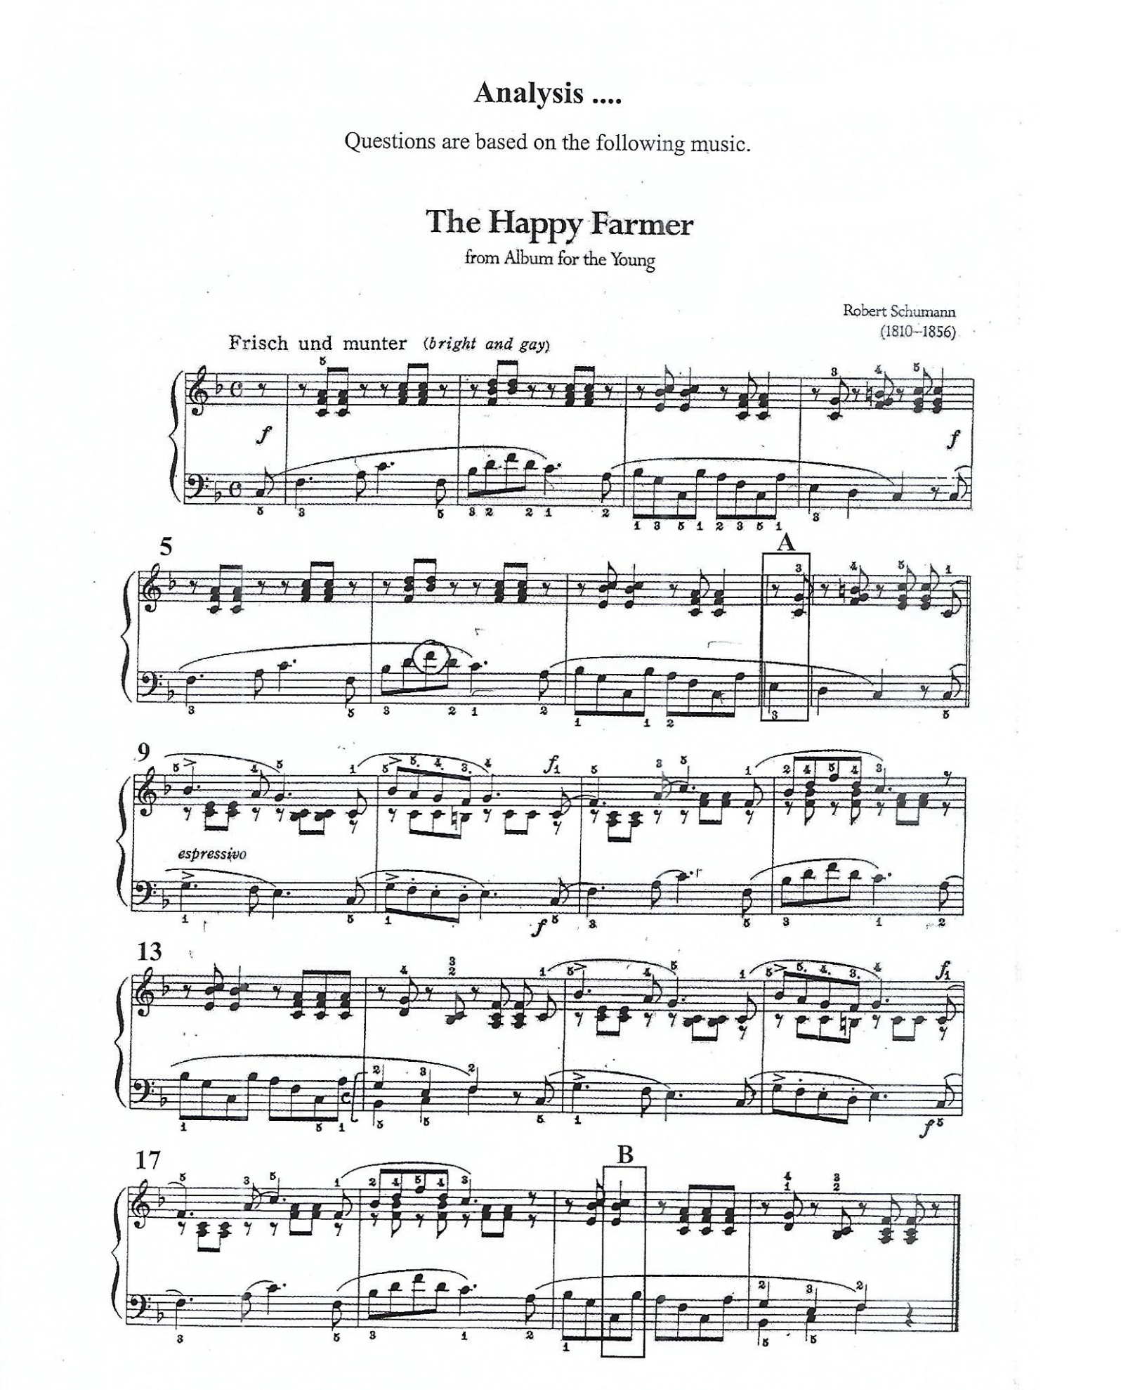**Part 2**

01. Compulsory Question

Analysis :- Questions are based on the following music ‘The Happy Farmer’ The Happy farmer is a piece taken from the Album for the young . Read it carefully and answer the questions on it.

01. The melody of the music is in the left hand. Right hand plays the accompaniment to the melody (Bass) write the melody from bar 1 to 4 with the Anacrusis, in the stave provided.

|  |
| --- |
|  |
|  |
|  |
|  |

02. Transpose the above melody one octave higher in the Treble clef.

|  |
| --- |
|  |
|  |
|  |
|  |

03. How many times does the main melody appear in the piece.

04. What would be the key of the given piece?

05. What is the relative key of the given piece?

06. Does the piece start on an upbeat or down beat?

07. Name 3 articulation marks that appear in the piece?

08. Underline the instrument which could play the melody of the above piece.

Recorder, Double Bass , Trumpet

09. Write the enharmonic equivalent to the circled note?

10. Select a suitable Tempo mark to the above piece?

Andante , Allegro , Lento , Prestissimo

***(10×2=20 Marks &***

**Section A**

Select one Question

02. A). Briefly describe variation form give examples ***(5 marks)***

B). Write the B melodic minor scale in the G clef , use key sign ascending and descending in minims.

|  |
| --- |
|  |
|  |
|  |
|  |

C). Name the following Intervals.

|  |  |  |  |  |
| --- | --- | --- | --- | --- |
|  |  |  |  |  |
|  |  |  |  |  |
|  |  |  |  |  |
|  |  |  |  |  |

D). Write the following traids. ***(5 marks)***

Use accidentals where necessary.

|  |  |  |  |  |
| --- | --- | --- | --- | --- |
|  |  |  |  |  |
|  |  |  |  |  |
|  |  |  |  |  |
|  |  |  |  |  |

A minor

tonic

triad

G major

Subdominant

triad

D major

Dominant

triad

triad

F major

mediant

triad

C major

tonic

triad

03. A). Write the main features of the music of the Romantic period. Name 03 composers, write their nationality, and name two works. ***(5 marks)***

B). Name the features of the Late Romantic Period, Name 02 composers, write their nationality, and name two works. ***(5 marks)***

C). Name the following Notes. ***(5marks)***

|  |  |  |  |  |
| --- | --- | --- | --- | --- |
|  |  |  |  |  |
|  |  |  |  |  |
|  |  |  |  |  |
|  |  |  |  |  |

D). Describe ‘Nadagam’ give examples. ***(5 marks)***

**Section B**

Select one question.

04. A). Write the Harmonic minor scale Descending ‘f # minor’ without key sign use Bass clef, using crotchets. ***(5 marks)***

|  |
| --- |
|  |
|  |
|  |
|  |

B). Describe ‘Nurthi’ give examples. ***(5 marks)***

C). Add necessary accidentals to make the following, the scale of ‘A melodic’ minor.

|  |  |  |  |
| --- | --- | --- | --- |
|  |  |  |  |
|  |  |  |  |
|  |  |  |  |
|  |  |  |  |

D). The nick name of the composers are given below. Identify and name the composer.

* Father of Symphony :-

* Infant Prodigy :-

* Father of Nurthi :-

* Poet of Piano :-

* Song Writer :-

05. A). Transpose the given melody an octave higher, so that it can be played on a Recorder.

|  |
| --- |
|  |
|  |
|  |
|  |

|  |
| --- |
|  |
|  |
|  |
|  |

***(5 marks)***

B). Describe Rondo form giving an example. ***(5 marks)***

C). Rewrite the given music extract in the same pitch using the Alto clef. ***(5 marks)***

|  |
| --- |
|  |
|  |
|  |
|  |

D). Complete the following bars with a rest / rests correctly grouped. ***(5 marks)***

|  |
| --- |
|  |
|  |
|  |
|  |